Restful API are nothing but, any API which follows all the principles given by REST are called restful api’s

The 6 Guiding Rules (Constraints)

To be truly "RESTful," an API should follow these six principles:

- Statelessness: The server doesn't remember anything about previous requests. Every single request from the client must contain all the information needed to understand it.
- Client-Server Separation: The "front-end" (client) and "back-end" (server) are independent. You can change the database without affecting the UI.
- Uniform Interface: All requests should look similar. This usually means using URIs (like /users/123) to identify resources.
- Cacheability: Responses should define themselves as cacheable or not to improve speed and reduce server load.
- Layered System: A client shouldn't be able to tell if it's connected directly to the server or to an intermediary like a load balancer or security layer.
- Code on Demand (Optional): The server can occasionally send executable code (like JavaScript) to the client

Web API’s or Restful api’s are used for performing CRUD operations.
An api perform inserting data, updating data, deleting data and reading data from different sources (database or other sources)

These operations are performed using a standard methods provided by HTTP protocol.

RESTful APIs use standard HTTP "verbs" to perform actions, often called CRUD operations:

HTTP Method | Action | Example
GET | Read | Retrieve a list of products or a specific user.
POST | Create | Add a new user or submit a form.
PUT | Update | Replace an entire resource with new data.
PATCH | Partial Update | Update just one field (e.g., changing only a password).
DELETE | Delete | Remove a resource from the server.

Python Rest frameworks

For developing web api/restful api’s using python language, python is provided various frameworks.

- DRF (Django Rest Framework)
- FAST API Framework
- Flask Restful Framework

Django Rest Framework (DRF)

Django rest framework is powerful toolkit provided on the top of django framework for developing web api’s or restful api;s using python programming language.

In REST API client communicate with server using various request methods provided by HTTP protocol.

Http Methods
- GET : Reading
- POST : Creating
- PUT : Update
- PATCH : Part update
- DELETE : Removing

What is advantage of using DRF (Django Rest Framework?)

Django rest framework provides the following features

- Easy to develop API’s
- Serialization of data
- Authentication and authorization
- Browsable API’s
- Pagination
- Filters and Searching
- Token based authentication (JWT)
- Powerful validation system

Basic steps for developing rest api/web api/web service
- Install django rest restframe work

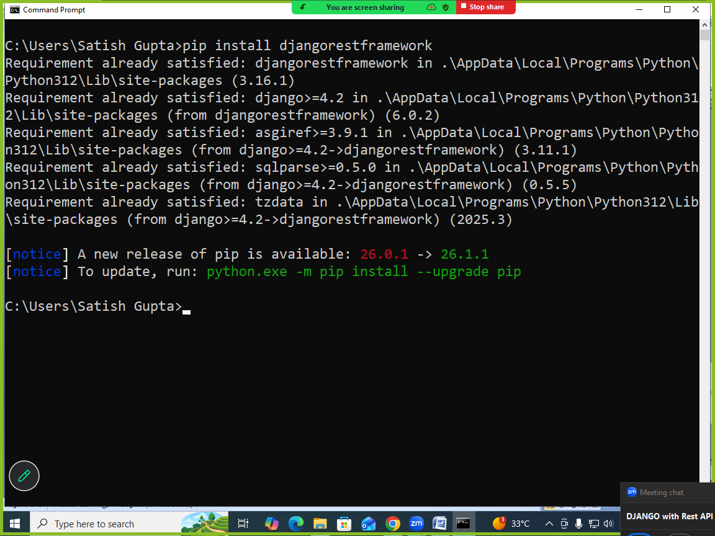

- Install rest_framework application by configuring in settings.py

INSTALLED_APPS=[….
‘rest_framework’,]

- Building API/REST API

Core Components
To build an API with DRF, you typically work with three main layers:
- Serializers: These act as the bridge between complex data (like Django model instances) and content types like JSON or XML. They also handle data validation for incoming requests.
- Views (or ViewSets): These handle the logic of the request. DRF offers APIView for fine-grained control and ViewSets to automatically handle common logic like "list," "create," "retrieve," and "update."
- Routers: When using ViewSets, routers automatically generate the URL configuration for your API, keeping your code clean and consistent.

PS C:\Users\Satish Gupta> cd D:\Backup\Django9amMar
PS D:\Backup\Django9amMar> django-admin startproject webapi1
PS D:\Backup\Django9amMar> cd webapi1
PS D:\Backup\Django9amMar\webapi1> python manage.py startapp api
PS D:\Backup\Django9amMar\webapi1>

Views.py
from django.shortcuts import render
from django.http import HttpResponse

# Create your views here.
import json
def listemployee(request):
employee=[{'empno':101,'ename':'naresh'},
{'empno':102,'ename':'suresh'},
{'empno':103,'ename':'kishore'}]
emplist=json.dumps(employee)
response=HttpResponse(emplist,content_type="application/json")
return response

urls.py
from django.contrib import admin
from django.urls import path
from api.views import listemployee
urlpatterns = [
path('admin/', admin.site.urls),
path('listemp/',listemployee),
]

Settings.py
INSTALLED_APPS = [
'django.contrib.admin',
'django.contrib.auth',
'django.contrib.contenttypes',
'django.contrib.sessions',
'django.contrib.messages',
'django.contrib.staticfiles',
'api',
]

This API’s are used client application and these client applications can be,
- Standalone Desktop Applications
- Mobile Applications
- Web Applications
- AI application

Developing client application (python language)
- Install library called “requests”

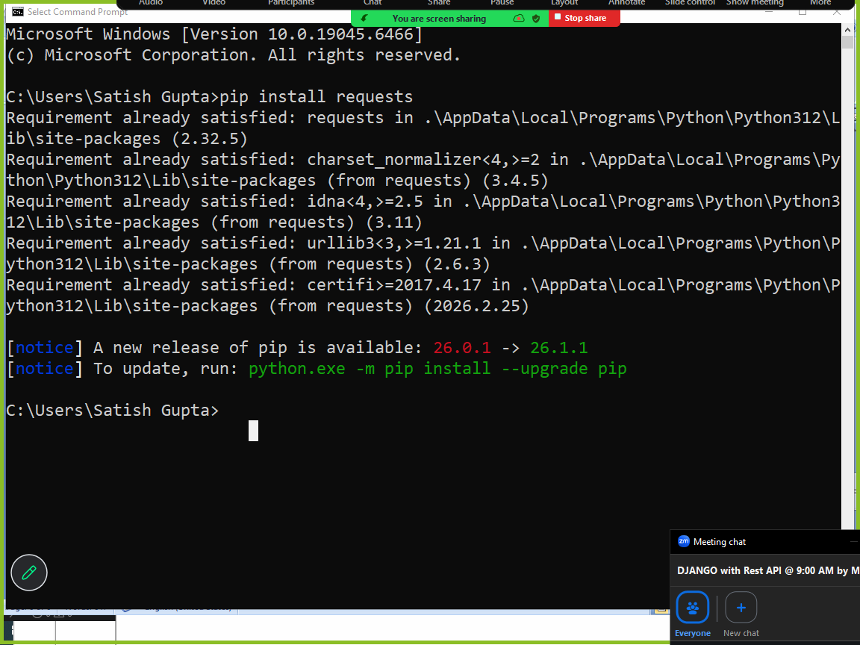

Write a client application/python program (IDLE)

# Client Application

import requests

BASE_URL="http://127.0.0.1:8000/"
END_POINT1="listemp/"
END_POINT2="getbal/4"
END_POINT3="view1/"

response=requests.get(BASE_URL+END_POINT1)
print(response.json())
response=requests.get(BASE_URL+END_POINT2)
print(response.json())
response=requests.get(BASE_URL+END_POINT3)
print(response.text)
Output
[{'empno': 101, 'ename': 'naresh'}, {'empno': 102, 'ename': 'suresh'}, {'empno': 103, 'ename': 'kishore'}]
{'msg': 'invalid accountno'}
<HTML>
<BODY bgcolor=yellow>
<h2>This is Response</h2>
</BODY></HTML>

Testing api from command prompt

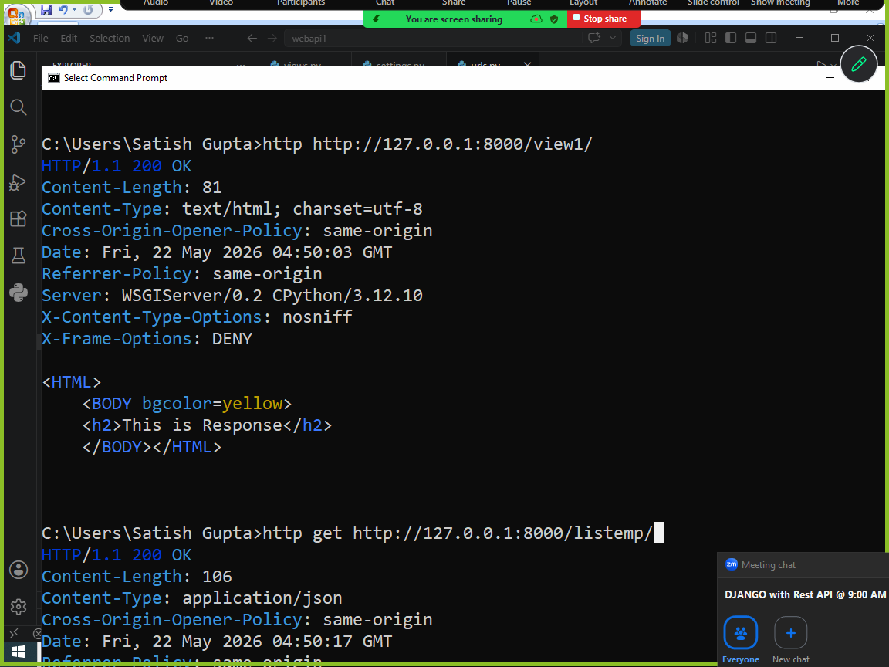

In order to http command install the following library

pip install httpie

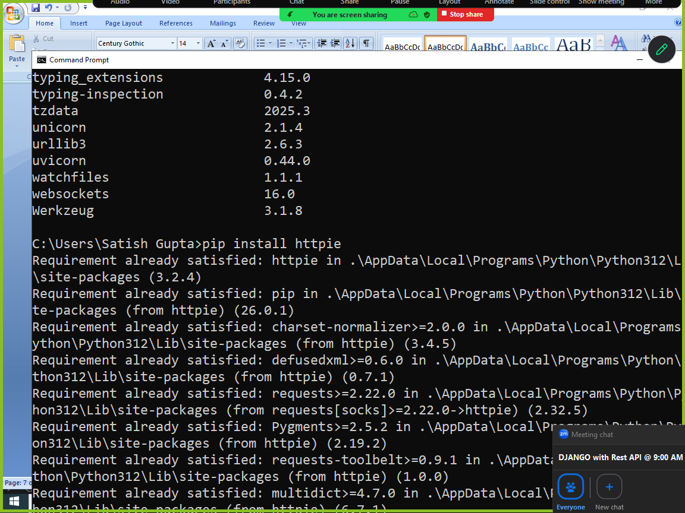

Serializers

Serializers are used for encoding and decoding
It is used for converting python objects into json and it allows convert json to python objects.

In the world of Django, serializers are primarily associated with the Django REST Framework (DRF). They act as the bridge between your complex database models and the simple formats (like JSON or XML) that front-end applications or other APIs can understand.

Think of a serializer as a translator:

Serialization: Translates database objects (QuerySets/Models) to JSON.
Deserialization: Translates incoming JSON to Database objects (after validating the data).

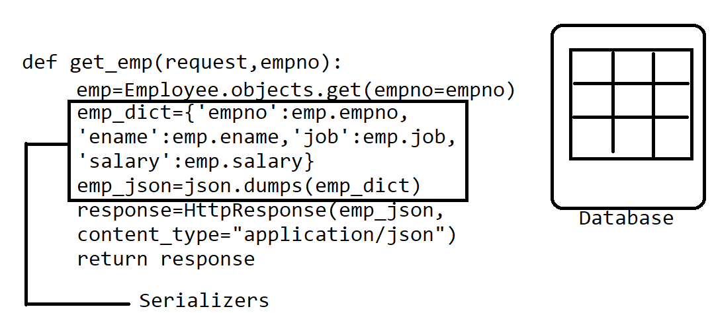

Serializers perform 2 operations
- Conversion
- Validation

Types of serializers
- Serializer
- ModelSerializer

Serializer

Serializer is a base class for creating custom serializers and builtin serializers .
Serializer is wrapper which converts python objects into json format.

Syntax:
class serializer_class(Serializer):
field-name=datatype
field-name=datatype
field-name=datatype

